PARISH NEWS
The Deverills & Crockerton
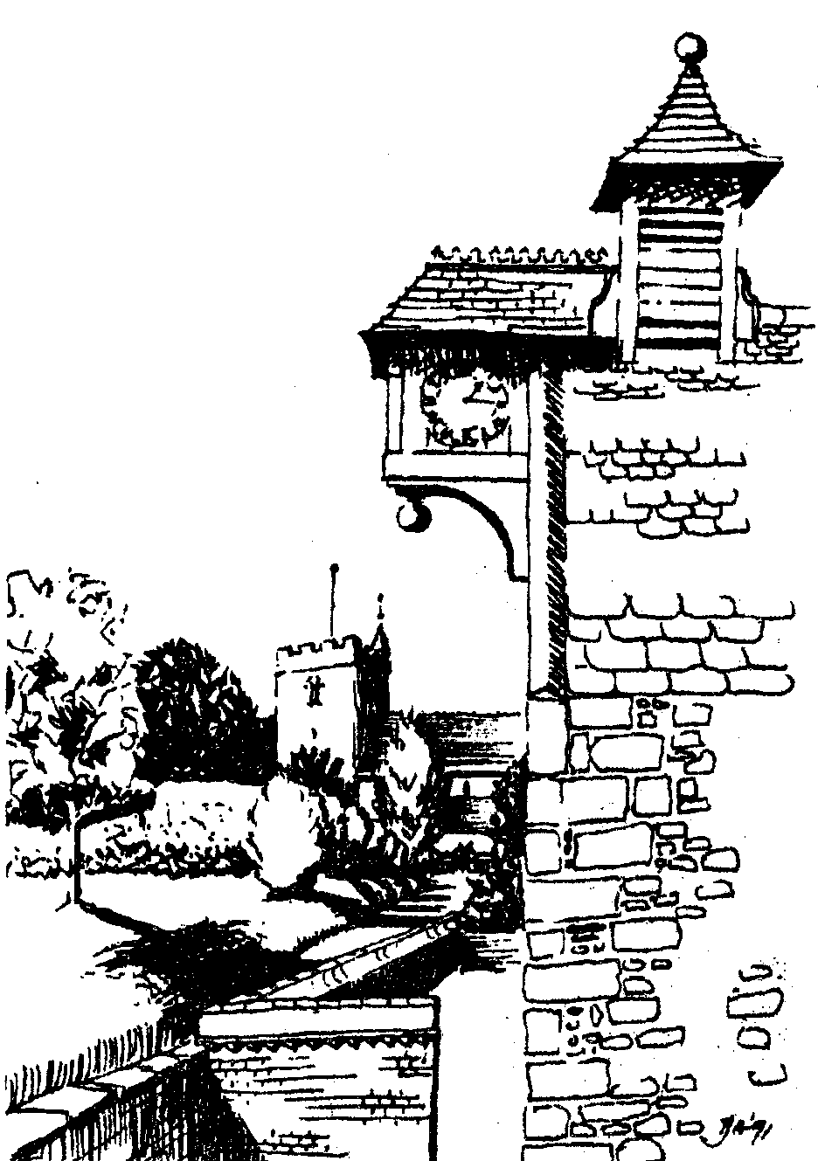

Alms House and Longbridge Deverill Church
by Pat Armstrong

November 2008

Look inside for local information
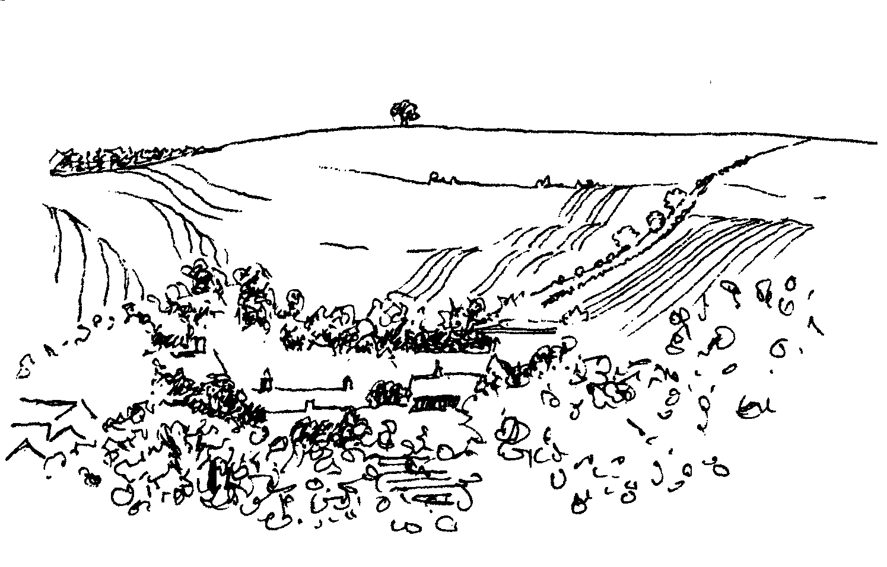

-2-

SAVE THE CHILDREN CHRISTMAS BAZAAR
Saturday 15th November from 10.00 am to 3.00 pm
At Mill Farm House, Hill Deverill
Home made produce, plants, bric a brac, cards, variety of stalls
Coffee and light lunches available
Come and enjoy relaxed shopping in lovely surroundings

Salisbury Theatre Club Trip
Monday 17th November
A Month in the Country by Philip Wilson
The cost is £17.00: theatre seat £12.00 and coach trip £5.00
Booking and payment in advance to Mary Stewart Cox Tel 840877
Longmead, Brixton Deverill, Warminster BA12 7EJ
Coach leaves Kingston Church 6.10 pm collects through the Deverills
Performance begins at 7.30 pm

BULL MILL ARTS CROCKERTON
CHRISTMAS EXHIBITION
22nd - 23rd and 29th - 30th November
10.00 am - 4.00 pm
Come and enjoy the show, find unique presents for Christmas!
Our vibrant exhibition features: jewellery, painting, sculpture,
printmaking, photography, gilding and lacquer work
Resident artists include: Sally & Chloe Alexander, Kate Andrew,
Nick Andrew, Olivia Clifton-Bligh, Stephanie Gilbert, Philip Leevers,
Daniel Petkoff and Joanna Sims
For further information please call 215628

CROCKERTON VILLAGE COMMITTEE & CROCKERTON SCHOOL
Children’s Carol Service Procession Tuesday 9th December 6.00 pm
Starting at Broadmead Lane progressing to Bath Arms Crockerton
A grand switch on of the Christmas Tree lights
And a blessing of the tree by our Rector Norma Payne
Carols, mulled wine and mince pies
All Welcome
Please bring a Christmas decoration or bird food for the tree

-3-

Remember, remember …….
The Rector writes:
November is very much a month for remembering. It begins with the church’s celebration of All Saints Day when saints through the ages are celebrated. This is followed by All Souls Day when those who have died are once more commemorated to God. It is a time when we especially remember those who have died during the past year.
Before we arrive at Remembrance Day, there is the fun, for some, of remembering Guy Fawkes on Bonfire night. A few days later, Remembrance Day follows. It seems more and more poignant as the years go on, that soldiers are still giving up their lives for the establishment of peace and justice. We hold them in esteem, and it is right to give over a particular time to unite in our gratitude for their sacrifice. The church year comes to an end this month with the celebration of Christ as King, and we begin to look forward to Advent and the beginning of the new church year, which leads quickly into Christmas.
It is a good time for reflection and for remembering. Reflections will doubtless include personal recollections of holidays and celebrations, disappointments and successes, even illness or life changing events. Remembering is important in our lives, a sort of putting-back-together of what often seem rather disparate and fragmented. In our brokenness it is necessary to look to what unites us and restores wholeness within our communities and within ourselves. For that, we have to look beyond ourselves to the things that give our lives meaning.
To know where we belong and to value all that makes us what we are will bring opportunities for discovery, the most important of which is discovering the Divine.
In your November remembering, may you see God in the work you do, in the earth you plough, the water you drink, the food you eat. May you see God in the faces of family and neighbours.
Norma Payne
NB Confirmation If you are interested and would like to know more about being confirmed please speak to Norma Payne (841321) or Di Britten (01373 832515).
Sudan - giving at no cost
Last year sales of Christmas cards in aid of Sudan, made from recycled cards, raised £5,000 in the Diocese. Sales of used postcards over the last three years has raised £36,000. Please, if you have any old cards put them in one of the three Deverill churches labelled SUDAN. The remade Christmas cards, by Jane Yates, will be on sale in the churches and at the Mothers and Toddlers Group.
Macmillan Biggest Coffee Morning
Many thanks to all who came to support this event. A big thank you to the Crockerton Garden Centre for having us, grateful thanks to all who gave and special thanks to all the helpers. Sum made was just on £800.
Janet Budgen

-4-
Poppy Appeal 2008
90 years ago on 11th November 1918, church bells across the country pealed in celebration as the Armistice was signed at the 11th hour of the 11th day of the 11th month. The Great War was over.
Today, thousands of our Armed Forces have been deployed to Iraq and Afghanistan, conflicts which have lasted longer than the Great War. Whilst the toll of dead and wounded will not reach the epic proportions of that war, barely a week goes by without news of new deaths and serious injuries to our gallant volunteer forces. Those involved in these tragic outcomes often face desperate futures and, therefore, most certainly deserve your support in order to give them and their families the best possible chance in future years. The Royal British Legion (RBL) is our leading contributor to this aim.
This year the collecting period will be from Saturday 25th October until Sunday 9th November which is Remembrance Sunday. During this period our volunteer RBL collectors will call at your home. People in the valley gave most generously last year raising a record sum from The Deverills and Crockerton. May I please ask you to once again give as generously as you can?
Robin Greenwood - Hon Organiser

Deverill Valley & Crockerton Women's Institute
Longbridge Deverill Hall
Monday 10th November 7.30 pm
‘Devon Tales with Humour’ by Raymond Guy
Presents for Green Lane Hospital patients - Refreshments served
Come and join us, you will be very welcome
For more information contact Ann Dufosee 840360

Longbridge Deverill Village Hall Events

WINTER LUNCH
Sunday 23rd November 12.30 pm for 1.00 pm
Warming casseroles & fabulous puddings
Bring you own wine
Tickets £10 (children under 5 free)
Call Sylvia Titt 214825 or Pat Wood 840535

COMMUNITY CAROL SINGING
Saturday 13th December at 5.00 pm
Come and join in our Christmas festivities

-5-

Upper Deverills Village Hall
Recent Activities
Our final income from the Fete was £588, the postponed Duck Race made £27 and the Eddie Mirzoeff film evening contributed £41. This means that with our recent summer activities and generous donations, we are able to report, after paying for the Hall extension, we have a healthy financial balance. Residents who attended Eddie’s evening were enthralled with his full-length film featuring a year in the life of the Queen. It gave a unique insight into public and private royal activities, showing a witty side to our Queen which is rarely seen, rightly winning two BAFTA awards. Thanks to his generosity there will be more such evenings.
Forthcoming Events
Friday 7th November 7.30 pm: Natural Africa
Slide Talk by Simon & Mandy Martyn. Exchange a dark November evening for 2 hours in the warmth of Africa, to see and discuss the complex web of life and how this is affected by the changes taking place all around us. Bread & cheese provided, for which contributions are welcome, but bring your own drink and glass.
Sunday 9th November at 12 noon: Remembrance Day Curry Lunch.
This will be a professionally prepared and served Curry Lunch with all the trimmings for £12 a head and has been timed to follow the Remembrance Service. Please contact Richard Cousens on 844970 to book your places and pay on the door. Do remember to bring your own Tiger Beer or wine.
Friday 14th November 7:30 pm: The Upper Deverills Quiz Night
Entry costs £3 per head to include bread and cheese so please bring your own drinks. Tables will be set up to make teams of no more than 4 and as usual you pay on the door.
Sunday 21st December 6:00 pm: The Upper Deverills Carol Service

You are invited to this traditional and very popular carol service that will be held, as usual, at the beautiful St Mary the Virgin Church, Kingston Deverill.
Finally, you may have noticed that we are not having Christmas Bingo this year due to lack of support in 2007 but we shall keep the event under review in future.
Albert Lee - Upper Deverills Village Hall Committee
Longbridge Deverill Village Hall
The Quiz Night at the Hall proved a testing but jolly evening. Congratulations to the winners of the cups (the usual table!). The chilli and baked potatoes were popular - sorry about the half-melted ice cream!
The Harvest Supper was well attended and all enjoyed the fare, particularly the mouth watering puddings! The committee particularly thank the donors of some of the puddings and raffle prizes, Mr and Mrs John Hurd for the generous amounts of watercress and Mrs Val Downing for the lovely table decorations.
Thank you to all those who come and make these evenings so sociable. We were very pleased to see some new faces at both events and hope to welcome them again.
Jo Nelson

-6-
‘Longbridge Deverill Parish Memories’ and Exhibition
An Exhibition of Bygones and Photographs will be open on Saturday 1st November from 12 noon until 6.00 pm in Longbridge Deverill Village Hall. Over a century of Parish life will be on display and the WI will be serving refreshments. There is to be no charge for this community ‘get together’ as it is funded by Awards for All.

The new local interest book ‘Longbridge Deverill Parish Memories’ compiled and published by the Longbridge Deverill Social History Group, will be on sale for the first time at the exhibition, there will be a further opportunity to obtain books the next day (Sunday 2nd November) from 11.30 am to 1.00 pm whilst the exhibition is being dismantled. Under the terms of the Awards for All funding received by the publishers, a free copy of the book will be given to each household in the civil parish of Longbridge Deverill which includes Hill Deverill and Crockerton. Any of these copies not collected that afternoon will be delivered in the Parish of Longbridge Deverill during the next week or two by volunteers, to whom the Social History Group is most grateful. Thereafter, books, priced at £8.00 each, can be bought from Group members: Ann & Ben Dufosee, Bill Hurd, Graham Read, Jill Russell, Jim White and John Wright.
Jill Russell 840209
Deverills Cricket Club
Kevin Peterson has enjoyed something of a golden period as England’s new cricket captain. Some of this magic has rubbed off on Pete Child who took over at the helm of the Deverills Cricket Club this season. Although on the face of it the weather this summer has not been that favourable, the Deverills have in fact enjoyed a successful season only losing a handful of fixtures to rain. This is a testament to the stalwart efforts of Groundsman and Club Chairman Jack May.
The Club has welcomed a number of new players this season from a wide spectrum of age groups. Readers may be interested to know that players now come from Kingston, Monkton, Brixton, Hill and Longbridge Deverills as well as Mere, Warminster and further afield. The last game of the season against Bratton was the occasion when the Club said farewell to Chris Richards from Mere who has performed with bat and ball for the Club over many years. Fittingly the match was an emphatic victory. The opening pair, Chris Richards and Ed Read, applied themselves building a century partnership which set up the eventual result.
At the recent AGM in The George, Longbridge Deverill, the Club Captain, Pete Child was able to reflect on a successful season, with more wins than last year and pronounced that the Club is in good heart and already looking forward to next season.
I know that everyone who has played this summer is very grateful to Julie Read and her team who have kindly provided such delicious teas.
Jamie Fagan

-7-

Longbridge Deverill Post Office
As a result of the consultation exercise earlier this year the Post Office is carrying out further local consultation before reaching a final decision. The purpose is to ensure that the appropriate Outreach Service is put in place to replace the current branch. Please note that the decision to close the existing branch has NOT changed. The proposal being consulted is for a Hosted Service, remaining at the current location, providing the standard range of products and services as now, and opening between 10.00 am to 3.00 pm on Mondays, Wednesdays and Fridays. 1st December 2008 is the closing date for this consultation. Dylys has the Post Office leaflets. Please write to FREEPOST CONSULTATION TEAM (no stamp required), or email to consultation@postoffice.co.uk Further details are at www.postoffice.co.uk.
Michael Mounde - District Councillor
Crockerton Forum
I know that we have been absent from recent editions of the Parish Newsletter but that doesn’t mean that things haven’t been happening. The most recent meeting of the Crockerton Forum was on 1st October, the one before having been on 25th June.
We continue to make progress with the ideas that are being put forward. The Broadmead parking trial was successful, with thanks going to the residents who provided feedback on this, and the school is continuing to move forward with the idea of getting staff cars off the road. We’re keen to make sure that this ‘off-road’ parking is still available once the new mobile has been sited.
In terms of communication, the minutes of the Crockerton forum are now available ‘on-line’. They will generally be loaded here a few days after having been circulated out to the forum members. They can be found at: www.deverills.org.uk
The next idea we are looking at is a revision of the ‘Traffic Management’ leaflet within the school. A copy of this, once it has been re-issued, will be made available to all the parents of children at the school, as well as the residents closest to the school. This will highlight the areas of ‘least impact’ for parking, as well as reminding people of some of the other schemes that are currently in operation around the school, such as the walk from Shearwater car park. We’re also looking at the practicality of trying to reduce speed limits around the school, but there’s a lot of investigation that needs to happen with this.
It’s interesting to note that our problems are not unique. Carol Clough raised the issue of parking at the Area Heads meeting recently, and it transpires that all the other schools have very similar issues, but Crockerton is leading the way in terms of ideas and initiatives. Some of you will also have seen the local PCSO in attendance on a number of occasions in the mornings and afternoons, he’s been a very welcome reminder of the need for careful driving and patience in the area.
The next meeting of the forum is 26th November and I look forward to bringing you further updates following that, but in the meantime if you have any questions please don’t hesitate to contact one of the resident volunteers or myself by mobile: 0789 4546477 or e-mail: GDZEBRA@YAHOO.CO.UK.
Graham Dopheide

-8-
SERVICES PARISH OF DEVERILLS & HORNINGSHAM
Sunday Fourth before Advent
2nd November Brixton - 8.00 am Holy Communion 1662
Canon Richard Askew
Longbridge - 10.30 am All Souls Service*
Rev Norma Payne
Horningsham - 5.30 pm All Souls Service
Rev Di Britten
Sunday Third before Advent
9th November Longbridge - 8.00 am Holy Communion 1662
Rev Norma Payne
Kingston - 10.50 am Remembrance
Rev John Goodden
Horningsham - 10.00 am Holy Communion 1662 (said)
Rev Norma Payne
Horningsham - 10.50 am Remembrance at War Memorial
Rev Norma Payne
Sunday Second before Advent
16th November Longbridge - 8.00 am Holy Communion 1662
Rev John Goodden
Brixton - 10.30 am Holy Communion
Rev Di Britten
Sunday Next before Advent
23rd November Longbridge - 10.30 am Holy Communion
Rev Norma Payne
Horningsham - 11.15 am Morning Prayer
Col Robin Chappell
Kingston - 6.00 pm Evening Prayer
Mr John Budgen
Sunday First of Advent
30th November Horningsham - 10.30 am Benefice Service
Rev Norma Payne
Sunday Second of Advent
7th December Kingston - 8.00 am Holy Communion (1662)
Longbridge - 10.30 am Morning Worship
Horningsham 10 - 11.30 am Advent Workshop
Horningsham - 5.30 pm Evening Prayer

Tuesday, Wednesday, Thursday, Friday Longbridge 8.30 am Morning Prayer
Wednesday Longbridge 10.15 am Holy Communion

*All Souls Service We hope those who wish to remember friends or family who have died, particularly in the past year, will join us for this service and for refreshments afterwards.

-9-

SERVICES PARISH OF CORSLEY & CHAPMANSLADE
Sunday Fourth before Advent All Saints
2nd November Corsley- 9.00 am Family Holy Communion
Rev Di Britten
Chapmanslade - 3.30 pm All Souls service
Rev Norma Payne
Sunday Third before Advent
9th November Chapmanslade - 9.00 am Holy Communion
Rev Di Britten
Corsley - 10.50 am Remembrance
Rev Di Britten
Sunday Second before Advent
16th November Chapmanslade - 9.00 am Holy Communion
Rev Norma Payne
Corsley - 6.00 pm Evening Worship
Rev Norma Payne
Sunday Next before Advent
23rd November Temple - 9.00 am Holy Communion 1662
Rev Di Britten
Corsley - 10.30 am Parish Service
Rev Di Britten
Sunday First of Advent
30th November Horningsham - 10.30 am Benefice Service
Thank you from Richard Yates
I was delighted and very touched to receive such a very generous cheque at our Harvest Festival service in October at Horningsham to mark my official retirement, having reached the landmark of three score years and ten! The generosity of the people from the parishes of the Cley Hill Villages is very humbling and although quite unnecessary, none the less very much appreciated.
It has been a real pleasure to be able to come and take your services from time to time over the past ten years, although my final retirement in February after my aneurysm in New Zealand was a little sooner and more immediate than I had envisaged! My recovery has been little short of miraculous, let it never be said that the power of prayer can be overestimated. Ernie, our Jack Russell, is delighted that master can once again take him for daily walks, although not quite as far as before. However, although I am retired I am delighted to say that I have been given ‘Permission to Officiate’. This means that I can still take services if asked to do so by the incumbent, Norma Payne, our Rector. She assures me in the New Year she will be calling on me now and again to take a service - so you haven't seen the back of me completely! Every blessing to you all, and again a very big "thank-you" to all those who contributed to my gift. My wife, Jane, also received a big bunch of flowers and a box of chocolates and I am glad that the terrific support that she has given me over the past years was duly marked, she joins with me in saying thank you to you all.
The Deverills & Horningsham Register
Funeral
Betty Rose Mean on Tuesday 14th October at West Wiltshire Crematorium
Baptism
Joseph David Carlile on Sunday 19th October at Longbridge Deverill

-10-

Ivy House St Denys Retreat Centre
Wednesday 5th November
House Quiet Day with Martyn Skinner ‘Praying in colour’
For more information please phone 214824

Church Cleaners for November
Kingston - Mrs Beilby & Mrs Noonan
Brixton - Mrs Blue & Mrs Edwards
Longbridge - Monday 3rd November 9.30 - 10.30 am - all helpers
Church Flower Arrangers for November
 | Kingston | Brixton | Longbridge
2nd Nov | Mrs Mounde | Mrs Marsh | Mrs Woodcock
9th Nov | Mrs Mounde | Mrs Burridge | Mrs Woodcock
16th Nov | Mrs Joy | Mrs Burridge | Mrs Woodcock
23rd Nov | Mrs Joy | Lady Walker | Mrs Woodcock
30th Nov | Advent – no flowers

CONTACT THE EDITOR AND WEBSITE
Parish News Editor - Judy Munro 844385
Contributions for the Parish News through my letterbox or
by post to Whitepits Lodge, Kingston Deverill, Warminster,
BA12 7HD or by Email: judymunro@tiscali.co.uk Thank you
Please remember the deadline is the 15th of every month

Website: www.deverills.org.uk Email address:info@deverills.org.uk
Website manager : Kate Wilkinson 844998
Contents: Parish News with church services, Parish Register, Events, Local News plus pictures and other information
Contact the Clergy
Please contact Rev Norma Payne (841321) or another member of the Clergy (see back page) if anyone is housebound and would like communion or a visit at home; or if you know of anyone who is ill and needs our prayers; or you wish to discuss any church matter.
Contact the office Administrator by email: office@cleyhill-team.org.uk or by telephone 210149.
-11-

2009 Wylye Valley Calendar
After the success of 2008’s calendar, sales raised £6,525 for Hope and Homes for Children, the 2009 edition is now on sale! Smaller this year, with 12 inch square photographs, it again covers the area from Wilton to The Deverills. March features a lovely picture of Brixton Deverill church. All proceeds will be donated to this international children’s charity based in the Wylye Valley, working across Africa, central and eastern Europe, transforming children’s lives who are orphaned, abandoned or vulnerable (Registered Charity No 1089490). You can purchase the calendar @ £8.95, including envelope, from Hallmark Cards, 12 -14 Market Place Warminster, or online at www.wishfordarts.co.uk and view the images, or by contacting me, Chris Lock, by phone 01722 790817.
Neighbourhood Watch - A word of warning.
A trailer was stolen in Kingston Deverill on 2nd October from outside Ron Dix’s cottage at approximately 11.00 pm. Richard, Ron’s brother who lives next door, heard the commotion and got up to see two Range Rovers one red and one blue making off with the trailer attached to one of the vehicles. The police were called and five cars responded. Officers came from Mere, Westbury and Warminster, some had clocked off from the evening shift but immediately joined in the search. The thieves headed towards Maiden Bradley. The police approached Maiden Bradley from three different directions covering all major and minor roads, tracks and by ways. Sadly the thieves slipped through the net, probably pulling off the road until all was quiet. A description of the trailer is red, eight foot long with a ramp on the back for loading quad bikes etc. with two silver wheels. Any information at all would be helpful to the police. Ron would like to offer his thanks to all the police officers in the search team, especially those who had just finished a nine hour shift. It is thought these vehicles had been cruising the village a short time before the theft. Make sure everything is locked up and do not fail to report any suspicious people to the police immediately.
I would also like to draw your attention to a security company, Sureshield/Brute Force Security, who are associated with Direct Response Security and St Johns Security, and are currently being investigated by Trading Standards at Bristol. They are companies that Regional Police Forces have had serious problems with in the past. They target older people and imply connections to Neighbourhood Watch, Group Four Security, the Police and Age Concern, offering a ‘free’ security system. There is a charge for the contract which may cost between £2,000 and £5,000. It is illegal for companies to offer police monitored alarm systems if they are not accredited or authorised to do so. Do not enter into any contract with a security company without taking advice as to their credibility first. You can contact Derek Barron, Alarms Manager, Wiltshire Police on 01380 734118 who holds a list of accredited alarm companies for advice.
I was sorry to hear that no one from the Deverills turned out to see our Police Community Support Officer, Ian Owen, when he hired the Kingston Deverill village hall on Saturday 4th October to discuss village issues with the residents. I would like to thank him for giving up his valuable time to help us in the villages.
Dizzy Bridge - Kingston Deverill Neighbourhood Watch

-12-
Warminster Festival - Saturday 1st November to Saturday 8th November
Many exciting events including an organ recital at the Minster, Gilbert and Sullivan with the Havant Light Opera at the Athenaeum, Classical concerts, Country and Western music, Young People’s event in the Park, Songs of Old Wiltshire, Talks, The Great War poetry reading, Wine Tasting, Picture Road Show, Children’s workshop and many more events. Tickets and information available at the Library, Three Horseshoes Walk, Warminster BA12 9BT (216022), for events at the Athenaeum tickets available at the box office (213891) open 10.30 am - 1.00 pm Monday to Saturday. Go along and enjoy all that is on offer.
Where have you been?
The Somerset Arms, Maiden Bradley
This is a tricky one. Living in Kingston Deverill, the Somerset Arms (844207) is our nearest pub so when we heard that it had changed hands, yet again, but this time it had been thoroughly refurbished we were optimistic. However two different sets of neighbours had given it a bit of a thumbs down. Their main complaints were that it wasn’t a country pub as such and that the food was not exciting. We then met some friends from Longbridge Deverill who sang its praises – the décor, the food and the homemade preserves – so we felt we must try it for ourselves.
First impressions are that it has certainly been refurbished; the bar retains its slate floor and open fire but what used to be the games area is now like a modernised country house reception room, all pale Farrow and Ball paints, sofas, unusual lighting and a trompe l’oeil of a library wall. The Farrow and Ball and the bare floorboards also extend to the dining area in the other side of the pub, where there is also a small, private dining room which seats twelve and can be hired out separately. It was a mid week lunch time when we visited and there were two other groups dining plus three ‘regulars’ at the bar. I had the two course menu (£9.95) - soup followed by a thick burger and chips. The soup was excellent and the burger good but the chips were a little undercooked. My husband had three courses (£12.95) – Welsh rarebit, sausage and mash (just one sausage to his dismay) and pear and apple crumble – all of which he enjoyed but he would have liked slightly larger portions! All the food is cooked to order, which is good but did involve a bit of a wait. Dogs are allowed in the bar but beware of occasional intrusions from Henry, the resident Great Dane, who bursts through the door (although he is tethered) and surveys the customers with a puzzled expression.
As far as I am concerned, the jury is still out on this one. We are tempted to give it another try in the evening – I would welcome comments by phone or email from any others who have tried it.
Next month I will have been writing this section for a year so I thought I would summarise the views I have received on recommendations to date, plus attempt a list of top ten of places to eat locally and give some examples of places to go for ‘Posh Nosh’. Please send your comments and suggestions to me by email at farthings.kd@btinternet.com or through my door at Farthings, Kingston Deverill.
Trish Shuler 844291

-13-

Nature Notes
So far October has been kind to us and last weekend went some way to making up for our lost summer; long may it last. The warmth over the weekend resulted in an influx of ladybirds. We had lots trying to come into the house hoping to over winter with us. I’m no authority on ladybirds, but I think they m ay well have been the harlequin variety which is an invader and bad news, as they eat our own native species. As well as ladybirds, there have been more butterflies around with the warm, dry weather. I have seen a good number of commas, brimstones and red admirals. Bees have been very busy too collecting pollen from the ivy near our back door; when I opened the door one bright morning the humming was so loud I first thought it was a motor of some kind not just bees!
Thankfully with this spell of warm dry weather the farmers have been able to catch up with the combining, straw baling and sowing; working well into the night to make up for lost time. The landscape has changed daily as fields turn from yellow to brown. The trees are turning colour too with the sycamores showing the best so far with reds, oranges and yellows. Some of the other trees, noticeably the oaks and beech, look as if their leaves have already died on the tree before showing much colour. The hawthorns have a good crop of berries on them in readiness for our winter visitors to arrive. They should be due any day now and I keep listening out for the “cha-cha-chack” call of the fieldfare. The other visitor is the redwing which has a penetrating “steep” call that can often be heard at night as they migrate in the cover of darkness.
The bird tables, or should I say the hanging feeders (we dispensed with the tables as it became more and more difficult to keep them clean), are getting busier. Greenfinches far outweigh any other species at the moment and as they tend to be more susceptible to disease, I am forever looking out for sickly birds. I try to keep the feeders as clean as possible but birds definitely do not possess any table manners, and you can certainly tell when they have been feasting on berries! Goldfinches are now coming back in good numbers and we have had tree sparrows too. The coal tits are still coming regularly as are the long tailed tits. The nuthatch that I mentioned last month is still around which is super, and the great spotted woodpecker came back this morning.
Tawny owls have started calling at night and I have heard a vixen too. These, as well as the rooks calling and the male pheasants squawking, are all such familiar autumnal sounds.
Finally, ‘my’ pair of roe deer did get back together and they have been joined by some more. I regularly see up to five grazing at the back of the farm. This morning there was a group which included two bucks and a doe with a pair of youngsters born earlier this year. And a hare visited our garden just this afternoon giving us a good view of those lovely black ear tips.
Jane Trollope (written on 14th October )

-14-
LOCAL COUNCILS, SOCIETIES, GROUPS etc.
Longbridge and Crockerton Parish Council
Karen Manfield 215526 (Chair) Peter Whithey 840347 (Vice Chair)
Helen Few 840119 (Clerk) Tom Minter 216909
Bill Hurd 840023 Elaine Pidgeon 212878
Julian Algar 840816 Graham Read 840296
Brian Marshall 214789
Upper Deverills Parish Council
Lady Felicity Wheeler 844683 (Chair) Ranald Blue 841374
Jacqueline Smith 840238 (Clerk) Patricia Shuler 844291
Sarah Fagan 844123 Robin Greenwood 840743
District Councillor
Shear Water Ward - Michael Mounde 844363
Longbridge Deverill Village Hall Committee
Jo Nelson 840784 (Chair)
Barbara Smith 840251 (Secretary) Sylvia Titt 214825 (Caretaker)
Upper Deverills Village Hall
Richard Cousens 844970 (Chair)
Mandy Martyn 844320 (Secretary) John Lea 844325 (Hall bookings)
Crockerton Millennium Committee
Marion Thomas 213739 (Chair)
Pre-School Children and Parents ‘Thursday Group’
Barbara Beilby 844995 (Chair) Sylvia Titt 214825 (Leader)
Deverill Valley & Crockerton W I
Ruth Sutton (President) Jill Russell 840209 (Secretary)

Sir James Thynne Almshouse
Mrs Sue Jackson 840322 (Steward)

Deverills Cricket Club
Jamie Fagan 844123 Peter Child 01963 34593

Wylye Valley Tennis Club
Colin Singer 213696
Wylye Valley Flower Club
Mrs Hazel Yate 215617 (President) Mrs S Scott 213689 (Programme Secretary)
Wiltshire Wildlife Trust
www.wiltshirewildlife.org
Elm Tree Court, Long Street, Devizes SN10 1NJ
Rural Community Beat Officer - Police Community Support Officer
PC Phil Bridge - PCSO Ian Owen - 0845 408 7000

FORTHCOMING EVENTS

F O R T H C O M I N G E V E N T S

- Hearing Loss Lip-reading Wednesdays Margaret Head (213259)
- Scottish Dancing Monday Evenings Aline Fry (841054)
- Badminton Mondays & Fridays 3.00 - 5.00 pm Alison Rymell (844819)
- Pre-school & Parents Group Thursdays 10.00 - 11.30 am See p14
- Poppy Appeal 2008 Saturday 25th October - Sunday 9th November See p4
- Warminster Festival Saturday 1st November - Saturday 8th November See p12
- Longbridge Deverill Parish Memories Exhibition Saturday 1st November See p6
- Longbridge & Crockerton Parish Council meeting 7.30 pm - Monday 3rd November Longbridge Village Hall See p 14
- Ivy House Quiet Day Wednesday 5th November See p10
- Natural Africa Friday 7th November See p5
- Tango Classes Saturday 8th November for information contact 01373 302348
- Remembrance Day Curry Lunch Sunday 9th November See p5
- Women’s Institute ‘Devon Tales with Humour’ Monday 10th November See p4
- Wylye Valley Flower Club ‘Christmas’ Tuesday 11th November See p14
- Upper Deverills Parish Council meeting 7.30 pm Wednesday 12th November
Upper Deverills Village Hall See p14
- Quiz Night Upper Deverills Village Hall Friday 14th November See p5
- Save the Children Christmas Bazaar Saturday 15th November See p2
- Salisbury Theatre Club Trip Monday 17th November See p2
- Winter Lunch Sunday 23rd November See p4
- Bull Mill Christmas Exhibition 22nd & 23rd, 29th & 30th November See p2
- Tango Classes Saturday 6th December for information contact 01373 302348
- Crockerton Children’s Carol Service Procession Tuesday 9th December See p2
- Community Carol Singing Saturday 13th December See p4
- Carol Service at Kingston Deverill Sunday 21st December See p5

-16-

PARISH OF THE DEVERILLS AND HORNINGSHAM
Churches
SS Peter & Paul the Apostles Longbridge Deverill (LD)
St Michael the Archangel Brixton Deverill (BD)
St Mary the Virgin Kingston Deverill (KD)
St John the Baptist Horningsham (H)
Rector
Rev Norma Payne, 6 Homefields, Longbridge Deverill 841321
Clergy
Rev Diana Britten, 69 Lane End, Corsley 01373 832515
Licensed Lay Ministers
Mr John Budgen, Woodlands, Sutton End, Crockerton 218203
Col Robin Chappell, 7 Elm Hill, Warminster 212153
Churchwardens
Mrs Elisabeth Atkinson, 133 Foxholes, Crockerton (LD) 212129
Mr Nigel Poole, 7 Homefields, Longbridge Deverill (LD) 840902
Mrs Mary Stewart Cox, Longmead, Brixton Deverill (BD) 840877
Major Mike Tulloch, Spring Cottage, Monkton Deverill (KD) 844381
Mr Tim Moore, Manor House, Church Lane, Horningsham (H) 844336
Lay Pastoral Assistant Co-ordinator
Rev Norma Payne, 6 Homefields, Longbridge Deverill 84l321
PCC Treasurer
Mr David Stratton, Manor Farm, Kingston Deverill 844549
PCC Secretary
Mrs Anne Honley, Dry Hill House, Crockerton 215956
Church Electoral Roll Officer
Major Mike Tulloch, Spring Cottage, Monkton Deverill 844381
Parish News Editor
Mrs Judy Munro, Whitepits Lodge, Kingston Deverill 844385
Organist
Mr John Budgen, Woodlands, Sutton End, Crockerton 218203
Tower Captain
Mr Stephen Young, 68 Highbury Park, Warminster 212796
Caretaker - Longbridge Church
Mrs Sylvia Titt, 7 Church Street, Longbridge Deverill 214825
Office Administrator (Mon -Thurs 10.00 - 12.00)
Mr Dick Collins, 22 Church Street, Warminster 210149

